Equality, Diversity and Inclusion Policy

Policy Cover Sheet
Please fill in the following details:
Policy Name | Equality, Diversity and Inclusion Policy
Version Number | V1
Policy Owner | Adam Carney – EDI Manager
Release Date | March 2023
Policy valid for | 2 years

Documents included:
Completed Checklist (below) | x
Policy text | x
Filled in EIA | x

Where should this policy be shared? All policies will be shared on the HUB.
The HUB
Net Consent
Website | x

Policy Checklist
Have you completed the following tasks:
Used the Microsoft Accessibility Checker
Used formatted headings
Used Arial 12pt font
Included numbered paragraphs
Included page numbers
Included alternative text for all images which accurately describe what’s in the picture
Checked for gender neutral language e.g. remove dinner ladies, workmen, he/she and replaced with servers, contractors, they.
Used the full phrase instead of the acronym at least the first time
Used the spelling and grammar check
Gained feedback from colleagues to ensure the policy is clear and accurate
Included any legal, social or organisational changes since the last policy review
Reviewed the connected policies to ensure they are still active
Filled in the change log
Listened to the policy using the accessible reader
Reviewed the policy flowchart
Informed the EDI Manager of upcoming policy deadlines

Sign Off: To be filled in by the named person only
 | Name | Date
SLT
Corporation (if required)
Trade Union
EIA

Change log
Version number | Changes description | Major changes? Y/N | Initiator | Rationale | Date of completion | New version number
V1 | Standard format | N | Adam Carney |  | March 2023 | V1

CONTENTS
1. INTRODUCTION 4
2. SCOPE 4
3. AIM 4
1. ROLES AND RESPONSIBILITIES 4
Increase Diversity 5
Foster Inclusion 5
What to Do If You Experience or Witness Discrimination: 6
Examples of Behaviour: 6
3. DOCUMENTS ASSOCIATED WITH THIS POLICY 7

INTRODUCTION
  - This policy sets out how the organisation will discharge its duty under the Equality Act 2010, including the Public Sector Equality Duty.
  - Additionally, this policy supports the Strategic Plan 2020 – 2025
  - For greater context for this policy please see our EDI Annual Report which includes staff and student data, EDI objectives and recommendations for further actions.
  - For the purposes of this policy the term “learner” includes all individuals receiving teaching through Hopwood Hall College, which includes learners on full-time funded courses, apprentices, learners paying for short courses.

SCOPE
  - This policy is for all staff, learners and visitors of Hopwood Hall College.

AIM
  - This policy sets out the expectation of staff, learner and visitor behaviour and organisational approaches regarding advancing equality, increasing diversity and fostering inclusion.
  - Hopwood Hall College has a legal duty to comply with the Equality Act 2010 which requires the organisation to: Prevent direct discrimination, also by perception or association, indirect discrimination, harassment, and victimisation.
  - Advance equality of opportunity and foster good relations between people who share a protected characteristic and those who do not share that characteristic.
  - The Equality Act 2010 protects 9 characteristics from discrimination: Age, Disability, Gender Reassignment, Marriage and Civil Partnership, Pregnancy and maternity, Race and Ethnicity, Religion and Belief, Sex and Sexual Orientation.
  - Please note that we work beyond the Equality Act 2010 and acknowledge that there are additional characteristics which mean that individuals may experience additional barriers to learning or employment which include, but are not limited to:Young parents, Offending status, Those with experience of the Care system, Gypsy, Roma, Traveler communities.
  - Hopwood Hall College have a legal duty to comply with the Public Sector Equality Duty 2011 and when exercising functions have due regard for the following: Eliminate unlawful discrimination, harassment and victimisation and other conduct prohibited by the Act; Advance equality of opportunity between people who share a protected characteristic and those who do not and Foster good relations between people who share a protected characteristic and those who do not.
  - Publish equality information annually about staff and learners to demonstrate compliance with the general equality duty; and Prepare and publish one or more equality objectives they think they should achieve in order to meet the general equality duty.
  - Hopwood Hall College have a legal duty to comply with the Gender Pay Gap reporting which is publish annually as prescribed by law.

Strategic Plan 2020 – 2025
The Hopwood Hall College Strategic Plan 2020 – 2025 outlines five core values and four strategic intentions. This EDI Policy will work towards the following:
- Integrity – advancing EDI is the right thing to do and we ensure all learners get what they need to succeed, which involves acknowledging all of their identities.
- Nurturing – we support staff and learners by ensuring equitable access to resources and opportunities.
- Enjoyment – people who can bring their whole selves to work or education and receive the support they need experience better outcomes both within their employment or education and personally.
- Ambition – we raise aspirations by focusing on communities or groups who experience barriers to work and education, ensuring that people from those groups can achieve their full potential.
- Sustainability – by ensuring all staff and learners are supported we retain talented and skilled staff, retain students through the duration of their course, and improves the College’s reputation as well as finances.
- Strategic Intention 1: Providers of excellent education and skills – staff with strong EDI skills can better support learners to achieve and encourages innovation throughout our working practices.
- Strategic Intention 2: Champions of inclusivity – this policy sets out our expectations of staff and learner behaviour which will lead to a culture of promoting equality, celebrating diversity and is inclusive of all, as well as promoting accessibility.
- Strategic Intention 3: Drivers of economic prosperity – education is the key to economic recovery for groups with barriers to employment; by focusing on being inclusive and having a widely representative college community we support local, regional and national goals to upskill those hard-to-reach communities and produce a highly-skilled workforce to meet changing economic needs.

ROLES AND RESPONSIBILITIES

Everyone will:
- Treat each other with respect and dignity for everyone’s identities and personhood.
- Raise their voice if they experience or witness inequality.
- Take personal responsibility to uphold the college’s values.
Staff will:
- Ensure staff and student needs are being met through adaption and reasonable adjustments in whatever service they provide.
- Contribute to the collection and review of appropriate data to evidence equality of experience of staff and students in their area, producing action plans to address any inequitable experiences, e.g. awarding gaps for students or inaccessibility of a service.
Students will:
- Advocate for themselves or others wherever inequality is present.

Increase Diversity
Everyone will:
- Take opportunities to learn from and work with people different to them.
- Raise their voice when opportunities are not open to all or do not reflect the diversity of our community.
Staff will:
- Ensure there is a diverse workforce and student body in their area through staff and student retention and progression.
- Utilise a variety of examples both written and visual e.g. names from a variety of backgrounds, pictures of people of different races or ethnicities, representation of disability.
- Raise awareness of different identities, backgrounds and experiences through their own work, promoting diverse voices in their teaching or practice.
Students will:
- Be open to learning about different experiences from their own.
- Support and respect each other, especially those from different backgrounds from their own.

Foster Inclusion
Everyone will:
- Actively include each other in all activities, in or out of the classroom.
- Review and reflect on any barriers to participating fully within our college, then take steps to dismantle those barriers.
- Celebrate the diversity of our community to ensure everyone feels like they belong and are represented.
Staff will:
- Ensure their team members have all reasonable adjustments needed to fully and effectively undertake their duties, support and encourage the use of reasonable adjustments.
- Adjust their lesson delivery to ensure all learners can access their course.
- Reflect on and take steps to remove barriers to learning.
- Ensure all learners adjustments are in place and accounted for in planning and delivery.
Students will:
- Work with all peers and members of our college community to promote a sense of belonging.

What to Do If You Experience or Witness Discrimination:
If you experience or witness discrimination, please refer to the Grievance Policy for staff, Speaking out (whistleblowing) Policy, or the Bullying & Harassment policy and procedure (Staff and Students).
Examples of Behaviour:
Outlined below are examples of both expected and unacceptable behaviour. These lists are not limited to the following points and are intended as illustrative examples rather than exhaustive criteria.

Expected behavior
- Using diverse examples, names and people in teaching examples or course materials.
- Highlighting diversity of the Hopwood Hall College population in marketing,
- Celebrating diversity by supporting events related to different cultures, identities and experiences,
- Encouraging different groups to work together in and out of the classroom,
- Providing accommodations for different needs e.g. alternative formats for documents or gender-neutral toilets.
- Raising aspirations for outgoing students to ensure all students understand they have the opportunity to achieve a positive destination,
- Diversifying the student and staff populations.

Unacceptable behaviour
- Use of slurs or name calling,
- Homophobia, biphobia or transphobia - including name calling, dismissing experiences, denying the existence or validity of identity,
- Sexual harassment,
- Any kind of child on child abuse, including bullying, physical abuse, emotional abuse, upskirting etc,
- Microaggressions,
- Racism,
- Religious intolerance,
- Commenting on other people’s bodies or appearance.
The guidance set out in the Code of Conduct, Professional Guidelines for Staff and Disciplinary Procedures will apply in the case of unacceptable behaviour related to EDI.

- MONITORING AND EVALUATION
  - Any equal opportunities data collected for applicants for job roles or staff will be stored in the human resources system with reporting anonymised to prevent identification of individuals.
  - Any equal opportunities data for students will be stored in the Tribal EBS system with reporting anonymized to prevent identification of individuals.
  - System access limited to authorised individuals for monitoring and reporting purposes.

Key contacts for EDI
- EDI Manager, answerable to Executive Director, Business and Student Support
- EDI Steering Group, chaired by Principal and includes key internal and external members who aim to improve EDI across the college.
- Governor with EDI portfolio

DOCUMENTS ASSOCIATED WITH THIS POLICY
- Safeguarding and Child Protection Policy
- Learning Support Policy
- Code of Conduct
- College Professional Guidelines for Staff
- Disciplinary Procedures
- Grievance policy and procedure
- Complaints Procedure
- Bullying and Harassment Policy and Procedure
- Speaking Out policy (whistleblowing)
- Data Protection Policy

Appendix

Glossary
Discrimination:
Direct Discrimination – an individual is treated less favourably than another person because of a characteristic they have.
Direct Discrimination by Perception – an individual is treated less favourably than another person because of a characteristic they are thought to have.
Direct Discrimination by Association – an individual is treated less favourably than another person because of they are closely connected to an individual with a protected characteristic, e.g. someone who cares for a disabled family member.
Indirect discrimination – a situation in which a policy, rule, condition or practice that applies to everyone particularly disadvantages people who shared a protected characteristic.
Harassment: any unwanted conduct which has the purpose or effect of violating an individual’s dignity or creating an intimidating, hostile, degrading, humiliating or offensive environment for that individual, and anyone else who witnesses it whether they share the relevant characteristic or not.
Victimisation: treating someone badly because they have done (or are going to do) a “protected act”, is perceived to have done a protected act, or associates with someone who has done a protected act. A protected act is making a claim or complaint under the Equality Act.

Policy Guidance
Timeline
Steps | Working Days
60 day reminder
(Re)Write policy
SLT sign off
30 day reminder
Corporation sign off (if required)
Trade Union sign off
Equality Impact Assessment
14 day reminder
Final adjustments by Quality
Policy active on all platforms
These timings are approximate and are intended to be a guideline. If your policy needs Corporation Board sign off please contact the Clerk to the Corporation Fatema Hussein for dates to submit your policy to the board for discussion.

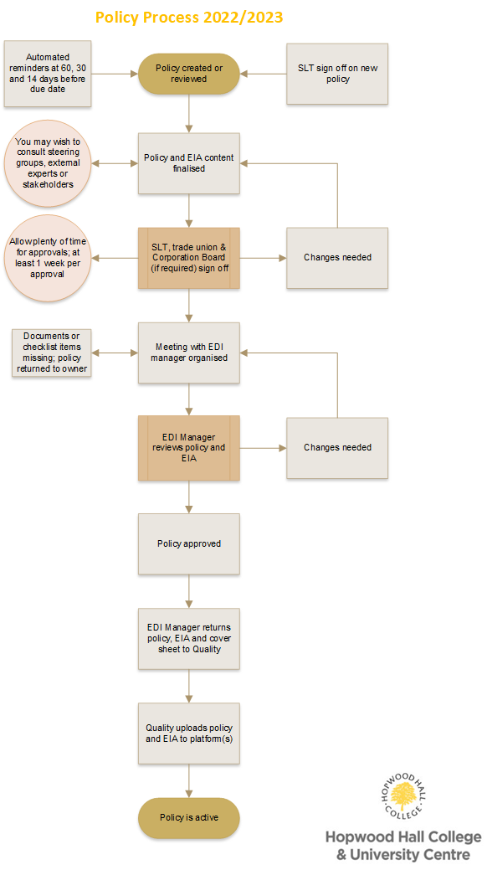
Policy Flowchart

